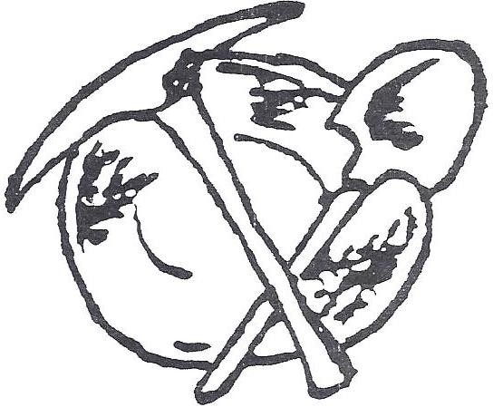
SUMPTER’S OUTDOOR

FLEA MARKETS
2022 Dates
Memorial Day Weekend – May 27, 28, 29 & 30
Forth of July Weekend – No Market at The Grounds
Labor Day Weekend – Sept. 2, 3, 4 & 5

Food, Crafts, Art, Collectibles, New Merchandise, Books and More
Sales 8 am till Dusk Admission is Free
For Vendor Reservations visit
cityofsumperor.com – Community (Tab) - Markets
Contact: Sumpter City Hall PO Box 68, Sumpter OR 97877
541-894-2314 or <cityofsumpteror@gmail.com>

