City of Sumpter, Oregon March 12, 2024

PROJECT BACKGROUND:
The City of Sumpter continues to grow requiring expansion of city supplied utilities. Sewer and water mainline extensions are required in the northwest section of the city, see the attached map for the exact project location.

PROJECT REQUIREMENTS:
- Water Mainline extension:

    - 600 ft, 6-inch C900 gasketed piping, installed at 4 ft deep, bedded and shaded.
    - Approximately 230 feet heading north to a 90-degree turn, then heading west for approximately 340 feet.
    - Installation of one fire hydrant at the terminus of the west line.
    - Line must be flushed, sanitized, and tested according to Department of Health, Drinking Water service regulations; followed by final connection.

- Sewer main:
    - 600 ft, 4-inch 3034 gasketed piping, installed to grade according to Oregon state code/regulations, bedded and shaded.
    - Two, 4-inch clean outs with traffic boxes.

- OTHER REQUIREMENTS:
Lines are to be spaced at minimum 10 ft apart.
All lines must be trace wired.
The project must begin no later than May 1, 2024

REQUIREMENTS FOR CONTRACTOR ELIGIBILITY
- Bids must reflect the prevailing wages required for this project.
- A current Oregon Construction Contractor’s license is required, provide CCB#.
- Bidder is responsible for obtaining additional project information or site examination to determine factors affecting cost, timeliness, and/or performance of the work.

Return sealed [in an envelope] bid documents, to the City of Sumpter, P. O. Box 68 or physical address 240 N. Mill St, Sumpter, OR 97877, by 3:00 pm, April 8, 2024.
Bids will be unsealed on April 9, at 4:15 pm.
The City of Sumpter reserves the right to reject any or all bids if the city believes it would not be in the best interest of the Project to make an award, whether because the bidder is unqualified, has doubtful financial ability, or fails to meet any other pertinent standard or criteria established by the City.
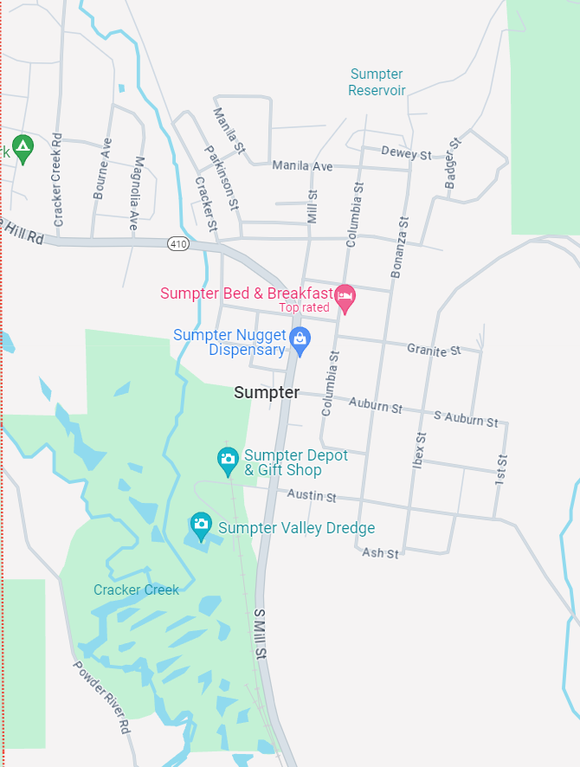
PROJECT LOCATION

